Medibot Manager: A Medical Chatbot Management System manages healthcare services via chatbots.

Project report submitted
For Review (Minor Project) in fulfillment of
The requirement for the degree of
Bachelor of Technology
(Computer Science and Engineering)
By
Deep Desai- 22000735
Saniya Gupta – 22000888
Diya Modi – 22000938

Guided By: Prof. Ujjwala Petigara


Department of Computer Science and Engineering
School of Engineering and Technology
Navrachana University, Vadodara
May 2022
CERTIFICATE

This is to certify that the project report entitled “Medibot Manager: A Medical Chatbot Management System manages healthcare services via chatbots.” submitted by “Deep Desai, Saniya Gupta and Diya Modi” to School of Engineering and Technology (SET) of Navrachana University Vadodara, in partial fulfillment for the award of the degree of B. Tech in Computer Science and Engineering (CSE) department. This report is a bona fide record work that has been carried out under my supervision during academic year 2024-25. The contents of this report, in full or in parts, have not been submitted to any other Institution or University for the award of any degree or diploma.

Prof. Ujjwala Petigara  Guide and Assistant Professor  Computer Science and Engineering  School of Engineering and Technology  Navrachana University, Vadodara  November 2024 | Prof. Ninad Bhavsar  Program Chair and Assistant Professor  Computer Science and Engineering  School of Engineering and Technology  Navrachana University, Vadodara  November 2024 | Dr. Ashish Jani  Head and Professor  CSE, IT, BCA and BSc DS  School of Engineering and Technology  Navrachana University, Vadodara  November 2024

Declaration

I declare that this written submission represents my ideas in my own words and where others' ideas or words have been included, I have adequately cited and referenced the original sources. I also declare that I have adhered to all principles of academic honesty and integrity and have not misrepresented or fabricated or falsified any idea/data/fact/source in my submission. I understand that any violation of the above will be cause for disciplinary action by the Institute and can also evoke penal action from the sources which have thus not been properly cited or from whom proper permission has not been taken when needed.

Name of the student | Student ID | Signature
Deep Desai | 22000735
Saniya Gupta | 22000888
Diya Modi | 22000938

Date: ___________

Acknowledgment

Every project big or small is successful largely due to the effort of several wonderful people who have always given their valuable advice or lent a helping hand. We sincerely appreciate the inspiration, support and guidance of all those people who have been instrumental in making this project a success. We are extremely grateful to Prof Ashish Jani, (Head- CSE, IT BSc-DS, BCA) and Prof Ninad Bhavsar (Program Chair- CSE) for entrusting our project “Medibot Manager” and giving us the opportunity to undertake such kind of challenging and innovative work. We feel deeply honored in expressing our sincere thanks to our Internal Project Guide Prof. Ujjwala Petigara for providing valuable insights leading to the successful completion of the project. We would also like to thank all the faculty members of CSE for their critical advice and guidance without which this project would not have been possible.

Last but not the least we place a deep sense of gratitude to colleagues and friends who have been a constant source of inspiration during the preparation of this project work.

Deep Desai- 22000735
Saniya Gupta – 22000888
Diya Modi – 22000938

LIST OF FIGURES

SR. NO. | TITLE | PAGE NO.
Fig 1.1 | E.R. Diagram | 11
Fig 1.2 | Use Case Diagram | 12
Fig 1.3 | Activity Diagram | 12
Fig 1.4 | Level 0 DFD | 13
Fig 1.5 | Level 1 DFD | 13
Fig 1.6 | Level 2 DFD | 13
Fig 2.1 | Architecture Diagram | 14
Fig 3.1 | Login | 15
Fig 3.2 | Home | 15
Fig 3.3 | Profile | 15
Fig 3.4 | Update Profile | 15
Fig 3.5 | Settings | 16
Fig 3.6 | Notification Settings | 16
Fig 3.7 | Password Manager | 16
Fig 3.8 | Privacy Policy | 16
Fig 3.9 | Help Centre – FAQs | 17
Fig 3.10 | Help Centre – Contact Us | 17
Fig 3.11 | Log-Out | 17
Fig 3.12 | Chat | 17
Fig 3.13 | Video Call | 18
Fig 3.14 | Home Page 1 | 18
Fig 3.15 | Appointment Booking | 18
Fig 3.16 | All Appointments | 18
Fig 3.17 | All Appointments 1 | 19
Fig 3.18 | All Appointments 2 | 19
Fig 3.19 | Cancel Appointments | 19
Fig 3.20 | Reviews | 19

ABSTRACT

The Medical Chatbot Management System (Medibot Manager) is a comprehensive platform developed to revolutionize healthcare service delivery. This system leverages artificial intelligence to integrate chatbot functionalities that facilitate seamless communication between patients and healthcare providers. Key features include online appointment booking, real-time interaction with doctors, patient record management, and multi-hospital registration, ensuring a centralized and efficient healthcare management experience.

The system is designed with robust data security measures, ensuring confidentiality and compliance with healthcare standards. Its multi-hospital support feature allows multiple institutions to collaborate on a shared platform, creating a unified ecosystem for patient care.

Medibot Manager addresses critical challenges in the healthcare domain, such as long wait times, limited access to medical professionals, and administrative inefficiencies. Patients can interact with the chatbot for services like booking appointments, accessing medical records, and receiving preliminary consultations. At the same time, healthcare providers benefit from optimized workflows, real-time patient data access, and reduced administrative overhead.

By improving accessibility, minimizing operational bottlenecks, and providing a user-friendly interface, Medibot Manager represents a significant advancement in digital healthcare. This report explores the system's development, architecture, functionality, and potential impact on modernizing medical services, ultimately contributing to a more efficient, patient-centric healthcare system.

Keywords: Medical Chatbot, Healthcare Management, Patient-Centric Care, Multi-Hospital Integration

Table of Contents

 | Title | Page No.
 | List of Figures | I-II
 | Abstract | III
1 | Project Title, Scope and Definition | 1
2 | Motivation | 2
3 | Literature Review | 3
4 | System Requirements for its Development and Production Environment. | 6
5 | Stakeholders | 7
6 | Approach Used | 8
7 | Data/Corpus/Data Dictionary | 10
8 | Project/Data Flow Diagram / UML | 11
9 | Architecture Diagram | 14
10 | Prototype/Fully Developed Implementation’s Screenshot. | 15
11 | Project Timeline | 20
12 | Conclusion | 21
13 | References | 22

- Project Title, Scope & Definition
Project Title:
Medibot Manager: Medical Chatbot Management System

Scope:
The Medibot Manager is designed to address key challenges in the healthcare industry by providing a fully integrated chatbot-based management system for hospitals and medical facilities. The project aims to enhance the efficiency of healthcare service delivery by enabling automated communication between patients and healthcare providers, simplifying administrative tasks, and improving overall healthcare accessibility.
Key features of the system include:
- Patient Interaction: AI-powered chatbots that facilitate appointment scheduling, medical consultations, and general inquiries, providing patients with immediate responses and guidance.
- Medical Records Management: Secure and centralized storage of patient records, accessible by both patients and healthcare providers, ensuring efficient tracking of medical histories.
- Doctor Scheduling and Multi-Hospital Integration: A unified platform that allows patients to book appointments with available doctors and interact with multiple hospitals registered on the system.
- Data Security and Compliance: Ensuring that all patient data is securely stored and adheres to industry standards and regulations, such as HIPAA.
The scope of the project extends to the development of both a mobile application and a web-based interface for healthcare professionals and patients, making the system adaptable for both personal and professional use.

Definition:
The Medibot Manager is a digital healthcare platform that leverages chatbot technology to manage and streamline various healthcare operations. The system provides a user-friendly interface for patients to interact with healthcare services, enabling them to book appointments, receive medical advice, and manage their health records without the need for direct human interaction. The system also assists healthcare professionals by automating administrative tasks, such as scheduling and patient management, thereby allowing medical staff to focus more on patient care.
The project will involve the following components:
- Web and Mobile Application: A responsive interface for both patients and healthcare professionals to access the system's features.
- Database Management: A secure system for managing patient data, doctor schedules, and medical histories.
- Security and Compliance: Strong encryption and adherence to healthcare regulations to ensure patient privacy and data protection.

- Motivation
The motivation behind the development of Medibot Manager stems from the growing challenges in the healthcare industry, such as long wait times, administrative inefficiencies, and limited access to healthcare professionals. With the increasing demand for healthcare services, especially in remote or underserved areas, there is a pressing need for innovative solutions to improve accessibility and streamline processes. Medibot Manager aims to address these issues by leveraging AI-driven chatbots to provide 24/7 access to healthcare services, enabling patients to schedule appointments, manage medical records, and receive real-time consultations without the need for direct human interaction. The system also reduces the administrative burden on healthcare providers, allowing them to focus more on patient care by automating routine tasks like appointment management and record-keeping. By integrating multiple hospitals into a single platform, Medibot Manager ensures that patient data is centralized, leading to better-coordinated and continuous care. The system not only improves the patient experience by providing instant responses and reducing wait times but also offers a cost-effective solution to make healthcare more affordable and accessible. In essence, the motivation behind Medibot Manager is to create a more efficient, accessible, and patient-centered healthcare system, harnessing the power of AI to improve healthcare delivery at scale.
At its core, Medibot Manager is motivated by the desire to enhance healthcare accessibility, efficiency, and quality. It aims to provide a scalable, cost-effective solution that can adapt to the growing needs of the healthcare sector. Ultimately, the project aims to empower both patients and healthcare providers by creating an automated, user-friendly system that facilitates better communication, reduces administrative burdens, and improves overall healthcare delivery. The integration of cutting-edge technology into this traditionally complex field reflects a forward-thinking approach to modernize healthcare and make it more patient-centric.

- Literature Review

Title: Empowring Hospitals For Better Patient Care Through Smart Management

Abstract
The healthcare industry faces numerous challenges, including long wait times, administrative inefficiencies, and difficulties in patient management, all of which can impact the quality of care provided. The project titled "Empowering Hospitals for Better Patient Care Through Smart Management" aims to address these challenges by integrating advanced technologies to enhance hospital operations and improve patient outcomes. This system leverages artificial intelligence (AI) and automation to streamline hospital management processes, providing real-time solutions for appointment scheduling, patient record management, doctor-patient communication, and multi-hospital coordination. By utilizing AI-powered chatbots, the platform enables efficient patient interaction, allowing patients to access medical advice, book appointments, and manage their health records without long delays. It also reduces the administrative burden on healthcare providers, ensuring that they can focus more on delivering high-quality care rather than handling routine tasks. The system ensures secure data handling, complies with healthcare regulations, and facilitates a unified platform for multiple hospitals to share patient information, improving care coordination and continuity.

Objectives of the study:
- Enhance patient experience and accessibility by providing 24/7 access to healthcare services and information.

Conclusion:
The "Empowering Hospitals for Better Patient Care Through Smart Management" project demonstrates how AI-driven technologies can improve hospital operations and patient care. By automating administrative tasks and enhancing communication, the system streamlines workflows, reduces costs, and improves efficiency. It enables 24/7 patient access, facilitates multi-hospital data integration, and ensures better care coordination. This solution fosters a more efficient, patient-centered healthcare environment, showcasing the potential of technology to transform healthcare management and meet the growing demands of both patients and healthcare providers.

Title: Modern Hospital Management System

Abstract
A Modern Hospital Management System (HMIS) is an advanced software solution designed to integrate and automate various administrative, clinical, and financial functions within a hospital or healthcare facility. This system streamlines the management of patient records, appointment scheduling, billing, inventory, and staff coordination, ensuring improved efficiency and better patient care. With features like centralized patient management, electronic medical records (EMR), automated billing, and inventory tracking, the system provides seamless access to real-time data for healthcare professionals. It also supports telemedicine integration, allowing remote consultations and follow-ups. Additionally, the system enhances operational transparency, reduces administrative workloads, and ensures data security in compliance with healthcare regulations.

Existing System
The existing hospital management systems often rely on manual processes or outdated software, with separate systems for patient registration, appointment scheduling, billing, and inventory management. These disconnected systems lead to inefficiencies, delays, and errors in patient care and administrative tasks. Patient records may be stored in physical files or unintegrated digital formats, making it difficult for healthcare providers to access comprehensive information in real time. Additionally, manual inventory management can cause stock issues. Overall, these traditional systems lack the scalability and automation needed to improve hospital operations and patient care, highlighting the need for a modern, integrated solution.

Proposed System
The Proposed Hospital Management System aims to integrate all hospital functions into a unified platform, improving efficiency and patient care. It features centralized patient management, AI-powered appointment scheduling, electronic medical records (EMR), integrated billing, and automated inventory management. The system also includes real-time analytics, telemedicine integration, and strong data security to ensure compliance. By automating key processes and providing real-time access to data, the system enhances operational efficiency, reduces costs, and improves coordination, making it a modern solution for meeting the growing demands of healthcare.

Conclusion:
The Modern Hospital Management System revolutionizes healthcare operations by integrating advanced technologies to automate and streamline processes. By centralizing patient data, improving appointment scheduling, optimizing billing, and automating inventory management, it enhances operational efficiency and reduces administrative burdens. The system ensures real-time access to critical information, fosters better coordination among departments, and improves patient care through features like electronic medical records (EMR) and telemedicine.
With robust security measures and compliance with healthcare regulations, the system safeguards patient information while facilitating seamless multi-hospital integration. By addressing the challenges of traditional methods, the Modern Hospital Management System empowers healthcare facilities to meet the growing demands of the industry, ensuring high-quality, accessible, and efficient healthcare services for all.

Title: An integrated approach to hospital management systems for enhanced operations and patient care in hospital management system

Abstract
The healthcare industry faces significant challenges in delivering efficient operations and ensuring high-quality patient care due to fragmented systems and outdated management processes. This project, titled "An Integrated Approach to Hospital Management Systems for Enhanced Operations and Patient Care", proposes a comprehensive solution that unifies critical hospital functions within a single, advanced platform. By integrating patient management, appointment scheduling, billing, inventory control, and electronic medical records (EMR), the system streamlines workflows and reduces administrative inefficiencies.This integrated approach transforms hospital operations, addressing existing challenges and empowering healthcare providers to deliver superior care. By optimizing efficiency and enhancing the patient experience, the system sets a new benchmark for modern, patient-centered hospital management.

Objectives of the study:
To Reduce Healthcare Costs: minimize operational expenses by automating repetitive tasks, improving workflow efficiency, and reducing human errors.

Conclusion:
The Integrated Hospital Management System presents a transformative solution to modernize healthcare operations and improve patient care. By unifying key functions such as patient management, billing, inventory control, and electronic medical records into a single platform, the system addresses inefficiencies and enhances operational workflows. Leveraging advanced technologies like AI, telemedicine, and real-time analytics, it enables seamless coordination, better decision-making, and 24/7 accessibility for patients and healthcare providers.

Title: - A Review of chatbot integration in hospital management system

Abstract
Chatbot integration in hospital management systems is revolutionizing healthcare by automating key processes and improving patient engagement. This study examines how chatbots streamline hospital operations, such as managing appointments, responding to patient inquiries, and providing preliminary medical guidance through AI-powered interactions. These virtual assistants reduce administrative burdens, enhance patient satisfaction, and enable round-the-clock support.The integration also facilitates real-time data exchange within hospital systems, ensuring seamless communication and better care coordination. Despite challenges like data privacy concerns and the need for advanced AI training, chatbots have proven to be a valuable asset in modern hospital management.

Objectives of the study:
To Analyze the Role of Chatbots in Hospital Management
To Measure Patient Satisfaction

Conclusion:
The integration of chatbots into hospital management systems represents a significant leap forward in modern healthcare. By automating routine tasks such as appointment scheduling, patient inquiries, and preliminary symptom assessment, chatbots enhance operational efficiency and reduce the administrative burden on hospital staff. Chatbots also streamline communication and data sharing within hospital systems, enabling better decision-making and resource utilization.
- System Requirements for its Development and Production Environment.

Operating System:
- Development: Windows 10/11, macOS, or Linux
- Production: Linux (Ubuntu Server, CentOS) or Windows Server

Development Tools and Frameworks:
- IDE: Visual Studio Code, PyCharm
- Frameworks: Django/Flask (Python), Node.js (JavaScript), React.js or Angular (Frontend)

Programming Languages:
- Python, JavaScript, or Java

Frontend:
- React.js, Angular, or Vue.js

Backend:
  - Django, Flask, or Node.js

Database:
  - MySQL, PostgreSQL, Firebase, or MongoDB

Version Control:
  - Git/GitHub

Hospital Management Features:
  - Patient Records, Appointment Scheduling, Inventory, Billing, and Telemedicine

Hardware Requirements:
  - Development: Intel Core i5+, 16 GB RAM, 500 GB SSD
  - Production: Multi-core processors (Xeon/EPYC), 32 GB RAM, Enterprise-grade SSDs

Additional Considerations:
- User Experience (UX): Intuitive UI design for easy navigation
- Security: SSL, data encryption, compliance with HIPAA/GDPR
- Scalability: Cloud platforms like AWS or Google Cloud

Testing Tools:
  - Selenium
  - Postman

- Stakeholders

- Primary Stakeholders:
Project Team:
    - DEEP DESAI
    - SANIYA GUPTA
    - DIYA MODI
Faculty Advisors:
    - Prof. UJWALA PETIGARA
College Administration:
    - Prof. Ashish Jani
Users:
    - College students and Faculty.

- Secondary Stakeholders:
- College Administration:
Ensures the system aligns with academic standards, monitors student activities, and manages permissions for training in hospital operations.
- Student Groups:
Utilize the system for hands-on training in hospital workflows, patient management, and administrative processes as part of their education.

- Approach Used

- Methodology:
The development of Medibot Manager: A Medical Chatbot Management System follows a structured approach to ensure seamless healthcare service delivery through chatbot integration.
    - Requirement Gathering:
- Identify user needs by consulting with patients, doctors, and hospital administrators.
- Define key features like chatbot-based appointment scheduling, symptom triage, and patient record management.
    - System Design:
- Architect a robust system integrating chatbots with hospital management functionalities.
- Design user-friendly interfaces for chatbot interactions and backend management.
    - Technology Selection:
- Choose AI tools like Dialogflow or IBM Watson for chatbot development.
- Opt for Python or JavaScript for backend logic and React.js for frontend development.
    - Chatbot Integration:
- Develop AI-powered chatbots capable of natural language processing (NLP) for patient interactions.
- Link chatbots to hospital modules for scheduling, medical records, and real-time notifications.
    - Development Phase:
- Implement core features like patient inquiries, symptom analysis, and doctor recommendations.
- Develop APIs to connect chatbot services with the hospital's existing systems.
    - Testing:
- Perform unit testing for chatbot responses and integration testing for seamless operation with other modules.
- Conduct user testing to ensure intuitive and accurate interactions.

    - Deployment:
- Deploy the system on cloud platforms for scalability and accessibility.
- Roll out the chatbot in phases, starting with basic functionalities and scaling to advanced features.
    - Monitoring and Feedback:
- Monitor chatbot performance and user satisfaction through analytics and feedback loops.
- Continuously improve chatbot accuracy and expand its capabilities based on user input.
    - Maintenance and Updates:
- Provide ongoing support to ensure smooth operation, resolve bugs, and introduce new features.
- Regularly update AI models to enhance chatbot performance.

  - Technology Stack:
    - Frontend:
- Frameworks: React.js, Angular, or Vue.js
- Methodology:
      - Languages:
- HTML, CSS, JavaScript
      - Tools:
- Bootstrap or Material-UI for responsive design
    - Backend:
      - Frameworks:
- Django/Flask (Python) or Node.js (JavaScript)
      - Languages:
- Python, JavaScript, or Java
      - API:
- RESTful APIs for communication between frontend and backend
    - Database:
      - Options:
- Firebase (NoSQL), MySQL, PostgreSQL, or MongoDB
- Purpose: To store patient records, appointment schedules, and chatbot interactions

- Data/Corpus/Data Dictionary

Attributes and Variables:
- Patient Information:
  - Patient_ID: Unique identifier for each patient (String/Alphanumeric).
  - Name: Full name of the patient (String).
  - Contact: Phone number and email (String).
  - Address: Residential details (String).
  - Medical_History: Details of previous treatments, allergies, and diagnoses (Text).
- Doctor Information:
  - Doctor_ID: Unique identifier for each doctor (String/Alphanumeric).
  - Name: Full name of the doctor (String).
  - Specialization: Field of expertise (String).
  - Availability: Consultation timings (DateTime).
- Appointment Details:
  - Appointment_ID: Unique identifier for appointments (String/Alphanumeric).
  - Patient_ID: Reference to the patient booking the appointment (Foreign Key).
  - Doctor_ID: Reference to the consulting doctor (Foreign Key).
  - Date_Time: Scheduled date and time of appointment (DateTime).
  - Status: Status of the appointment (e.g., Confirmed, Pending, Cancelled) (String).
- Chatbot Interactions:
  - Chat_ID: Unique identifier for each interaction (String).
  - User_ID: Identifier for the patient or staff interacting with the chatbot (Foreign Key).
  - Query_Type: Type of query (e.g., Appointment, Symptoms, Billing) (String).
  - Response: Chatbot’s generated response (Text).
  - Timestamp: Time of the interaction (DateTime).
- Billing Information:
  - Bill_ID: Unique identifier for each bill (String).
  - Patient_ID: Reference to the patient (Foreign Key).
  - Services: List of availed services (Text).
  - Total_Amount: Final amount payable (Float).
  - Payment_Status: Paid or Pending (String).
- System Logs:
  - Log_ID: Unique identifier for each log (String).
  - Action: Description of the action performed (Text).
  - User_ID: Identifier of the user initiating the action (Foreign Key).

- Project/Data Flow Diagram / UML

E.R. Diagram:
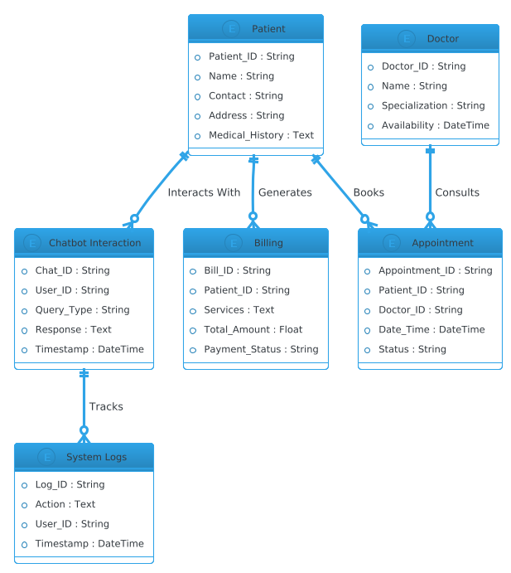

Fig 1.1: E.R. Diagram

Use Case Diagram:

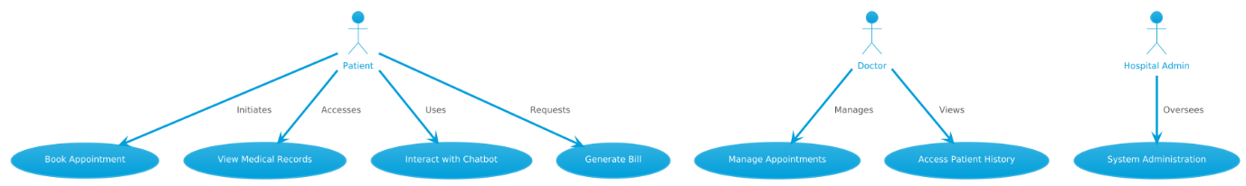

Fig 1.2: Use Case Diagram

Activity Diagram:

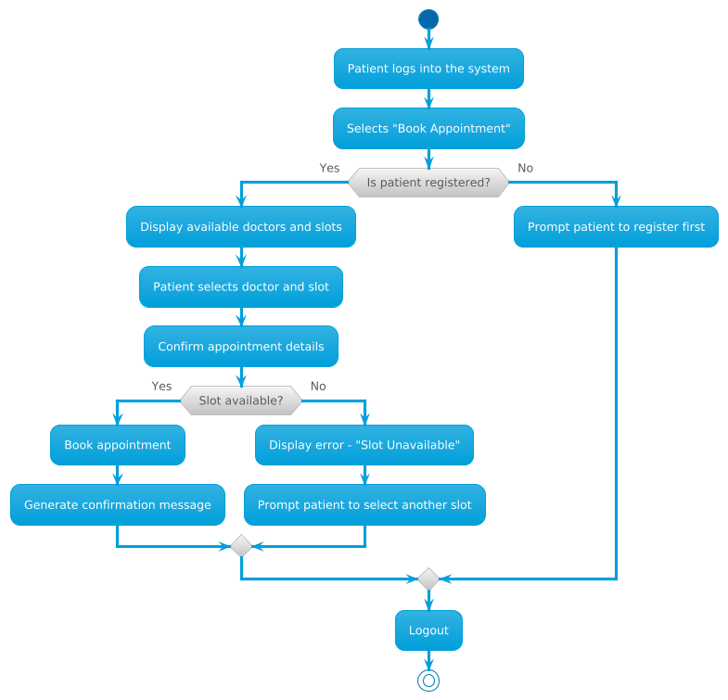

Fig 1.3: Activity Diagram

Data Flow Diagram:

Level 0:

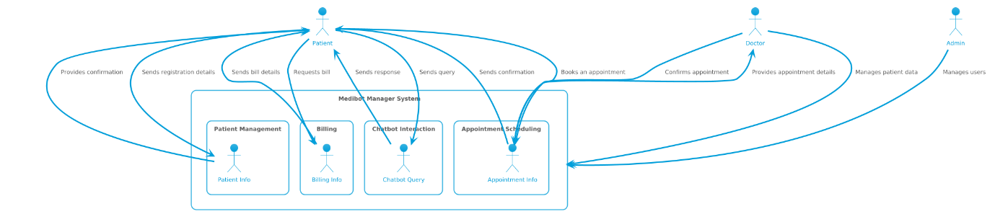

Fig 1.4: Level 0 DFD

Level 1:

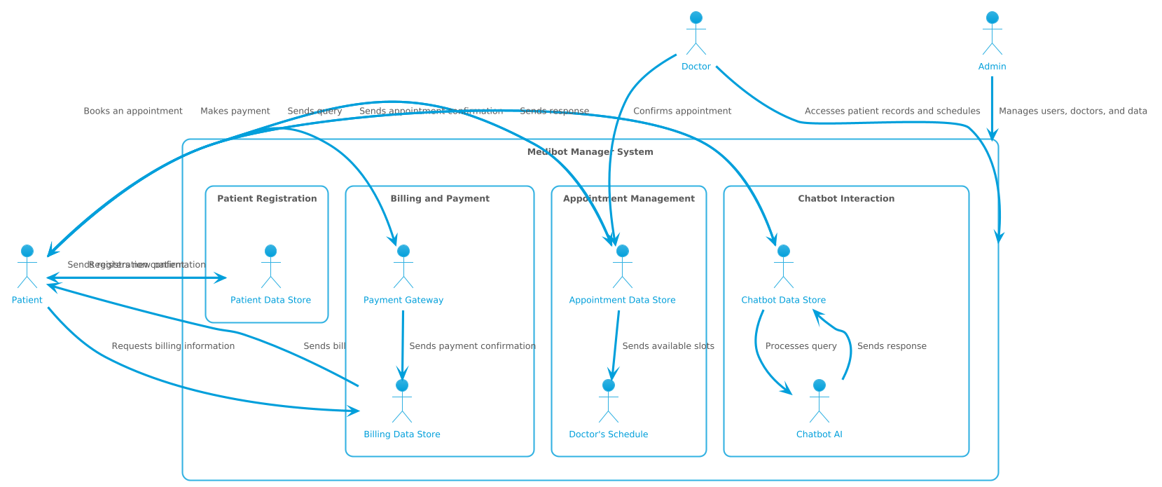

Fig 1.5: Level 1 DFD

Level 2:
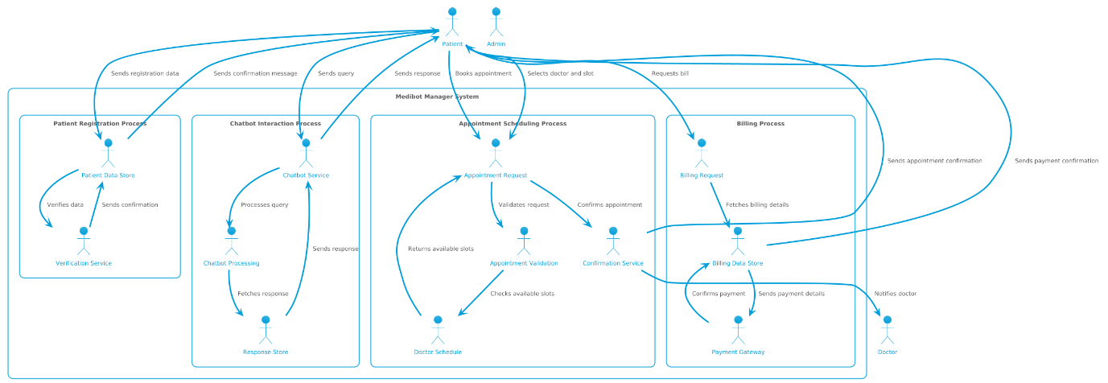

Fig 1.6: Level 2 DFD

- Architecture Diagram

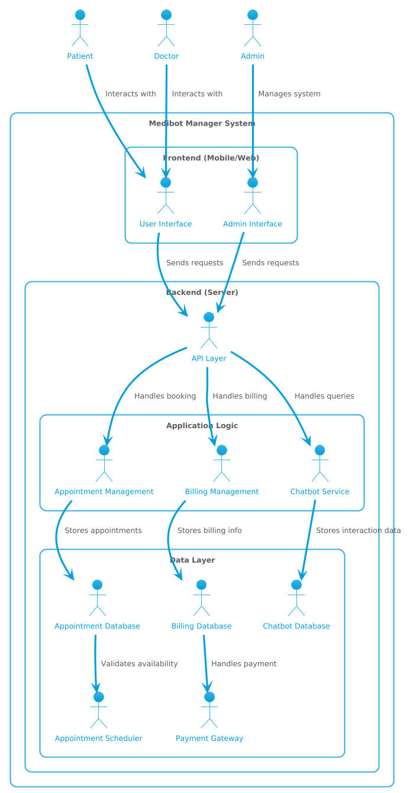

Fig 2.1: Architecture Diagram

- Prototype/Fully Developed Implementation’s Screenshot.

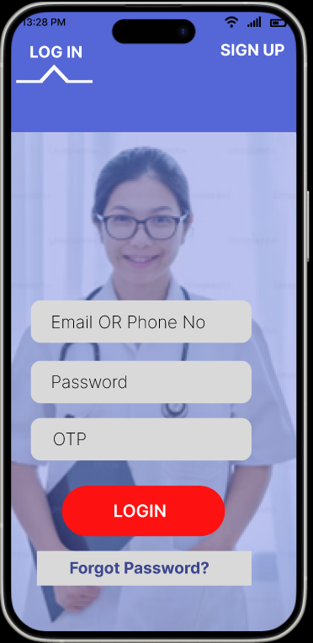  Fig 3.1: Login | 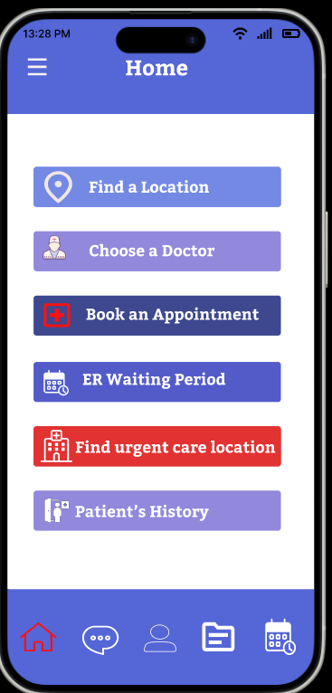  Fig 3.2: Home
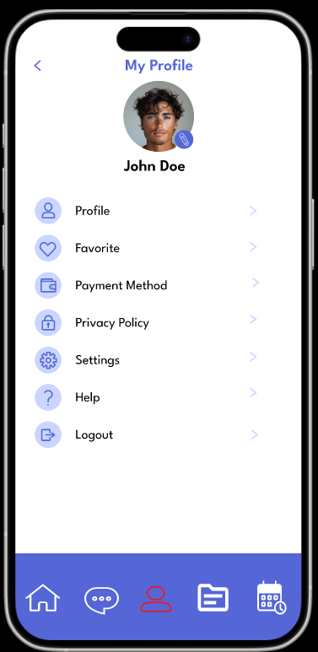  Fig 3.3: Profile | 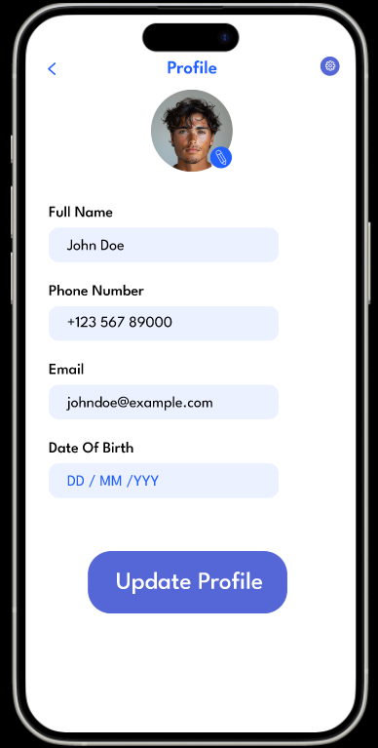  Fig 3.4: Update Profile

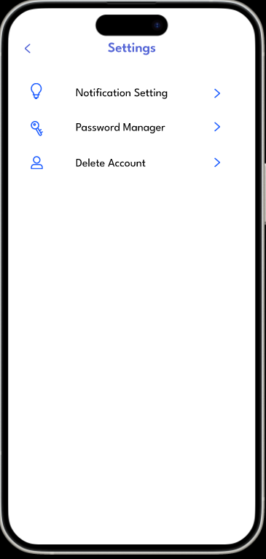  Fig 3.5: Settings | 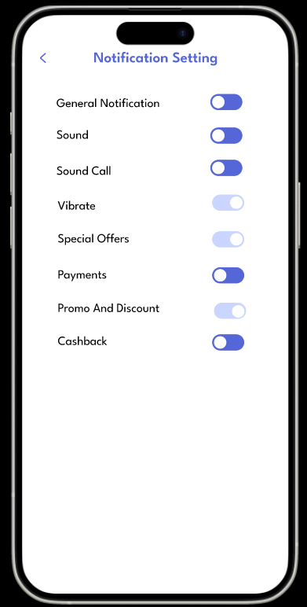  Fig 3.6: Notification Settings
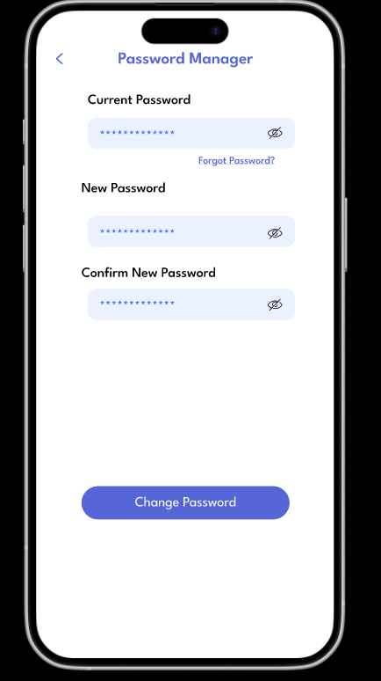  Fig 3.7: Password Manager | 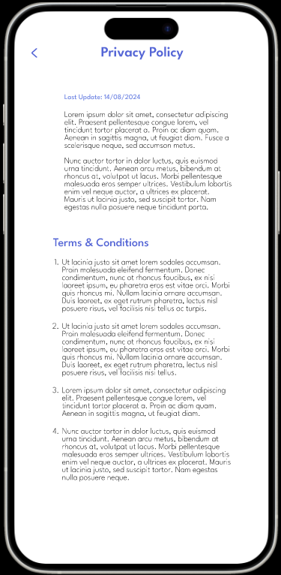  Fig 3.8: Privacy Policy

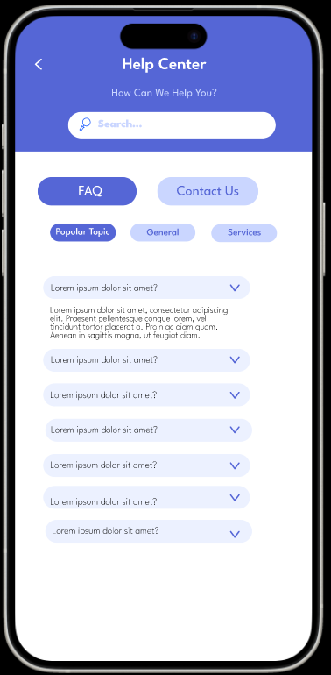  Fig 3.9: Help Centre – FAQs | 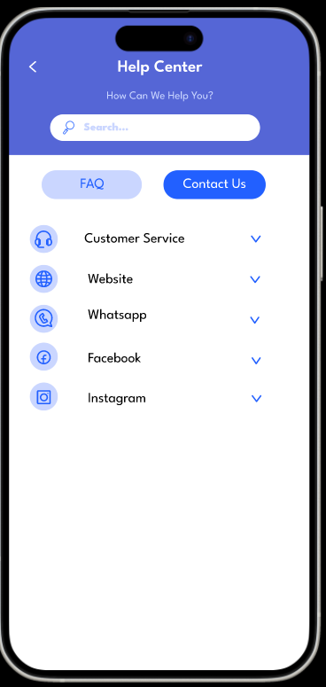  Fig 3.10: Help Centre – Contact Us
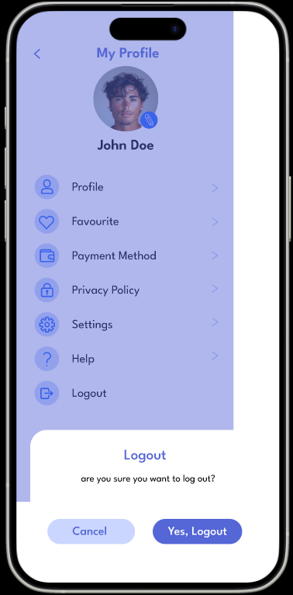  Fig 3.11: LogOut | 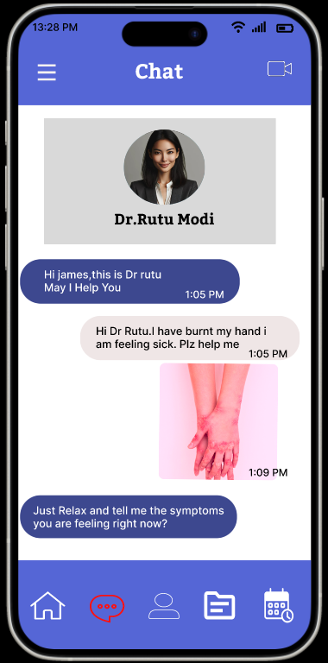  Fig 3.12: Chat

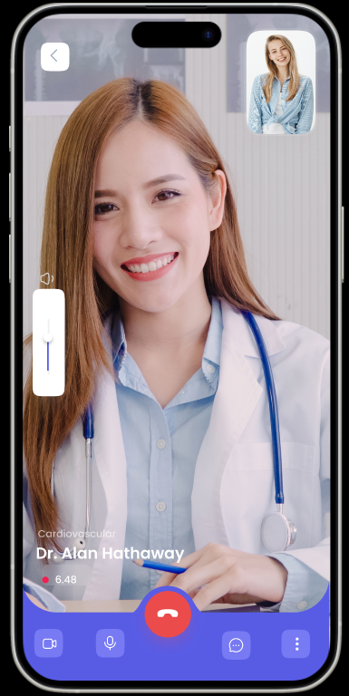  Fig 3.13: Video Call | 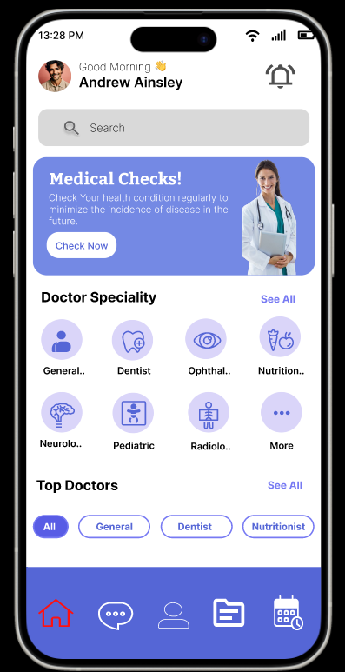  Fig 3.14: Home Page 1
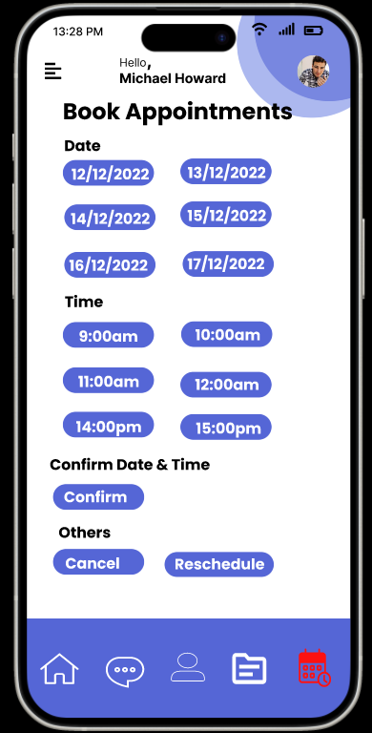  Fig 3.15: Appointment Booking | 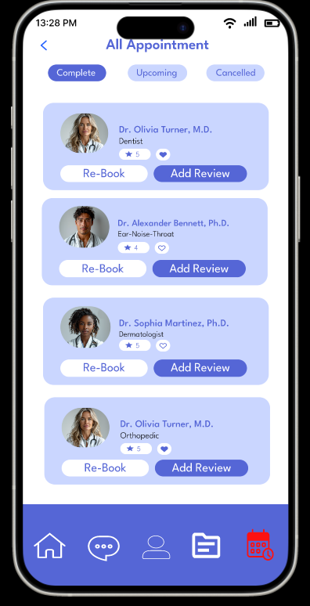  Fig 3.16: All Appointments

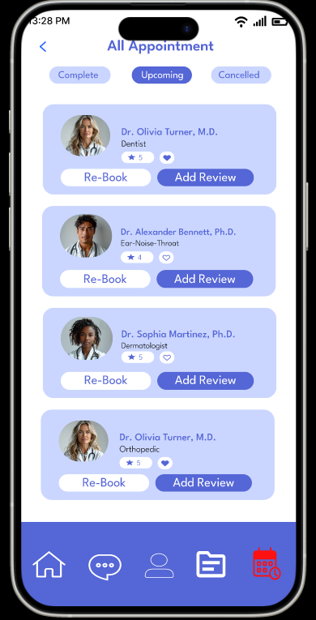  Fig 3.17: All Appointments 1 | 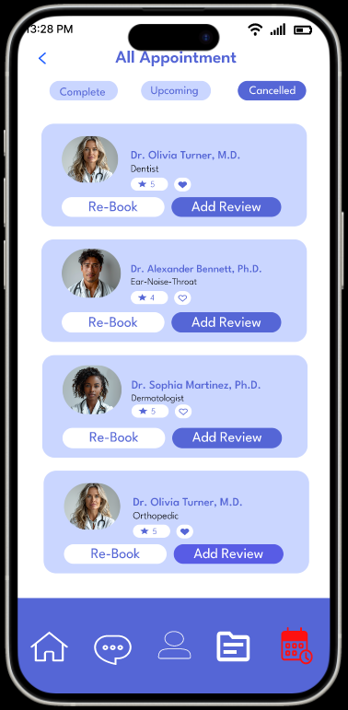  Fig 3.18: All Appointments 2
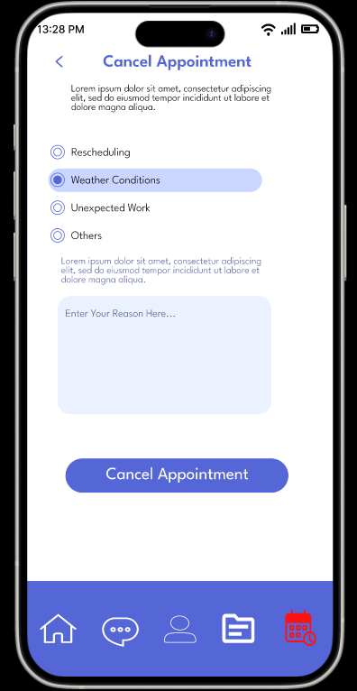  Fig 3.19: Cancel Appointments | 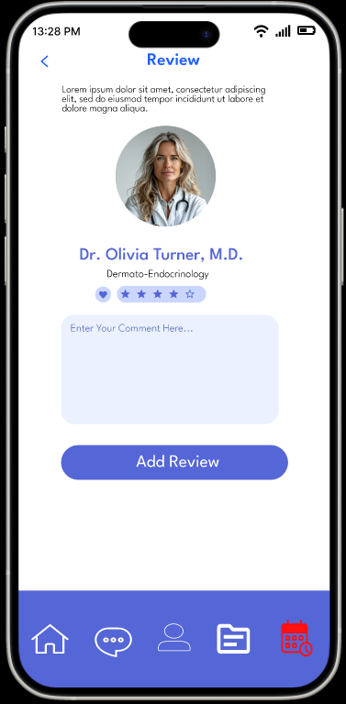  Fig 3.20: Reviews

- Project Timeline

- Project Planning and Requirement Analysis (Weeks 1–2)
  - Define project scope and objectives.
  - Gather system requirements from stakeholders.
  - Develop initial project plan and timeline.
- System Design (Weeks 3–5)
  - Create system architecture diagrams (E-R, use case, activity).
  - Finalize database schema and design.
  - Plan frontend and backend design.
- Development Phase 1: Backend and Database (Weeks 6–9)
  - Set up the database and implement core tables.
  - Develop backend APIs for user authentication, chatbot processing, and appointment scheduling.
- Development Phase 2: Frontend and Chatbot Integration (Weeks 10–13)
  - Create the user interface for patients, doctors, and admins.
  - Integrate chatbot features for query handling.
- Testing (Weeks 14–15)
  - Perform unit, integration, and system testing.
  - Fix bugs and optimize performance.
- Deployment and User Training (Weeks 16–17)
  - Deploy the system to the production environment.
  - Provide training and documentation to stakeholders.
- Maintenance and Feedback (Ongoing)
  - Gather feedback from users.
  - Implement updates and fixes as required.

- Conclusion

The Medical Chatbot Management System offers a transformative approach to hospital operations by integrating intelligent chatbot technology with traditional healthcare management. It enhances patient care by providing 24/7 assistance, streamlining appointment scheduling, and maintaining accurate patient records. Doctors and administrators benefit from simplified workflows, reducing manual effort and improving efficiency.

The system fosters better communication between patients and healthcare providers, ensuring timely and effective medical services. As a scalable and user-friendly solution, this project demonstrates the potential of technology in addressing real-world challenges in healthcare, paving the way for smarter, more accessible medical services.

- References

- Topol, E. J. (2019). Deep Medicine: How Artificial Intelligence Can Make Healthcare Human Again. Basic Books.
- Davenport, T., & Kalakota, R. (2019). "The potential for artificial intelligence in healthcare." Future Healthcare Journal, 6(2), 94–98.
- Adamopoulou, E., & Moussiades, L. (2020). "An Overview of Chatbot Technology." IFIP Advances in Information and Communication Technology.
- Dale, R. (2016). "The return of the chatbots." Natural Language Engineering, 22(5), 811–817.
- Rumbold, J. M. M., & Pierscionek, B. K. (2018). "AI ethics in healthcare: Privacy and bias." BMC Medical Ethics, 19, 81.
- Gordon, W. J., Fairhall, A., & Landman, A. (2019). "Risks of AI in healthcare." BMJ, 366, l4473.
- Accenture. (2018). "Artificial Intelligence: Healthcare's New Nervous System."
- HIPAA Journal. (2023). "What is the HIPAA Privacy Rule?"
- McKinsey & Company. (2022). "AI in healthcare: Transforming the patient experience."
- IBM Developer. "Building AI-Powered Chatbots."
- HIMSS. (2023). "Interoperability in Healthcare: Benefits and Challenges."

